Example of related records in UNIMARC | 

Alma supports related records in UNIMARC. Below is an example of how this may be done. In addition to the example below, other methods may be used.

See below three sections:
- The records
- The Alma Search
- The Primo GetIt tab with related title information

The records:

We have three bibliographic records:

- Title ‘Graduate Texts in Mathematics’; MMSID 99145511100121; System Control Number (field 035) 000192483
  - This is the main series record
  - Position 8 of LDR has “1” for ‘Highest Level Record’
  - This record has no inventory
- Title ‘Modern Geometry- Methods and Applications’; MMSID 99145511000121; System Control Number (field 035) 000004695
  - This record links to the series ‘Graduate Texts in Mathematics’ using a 410 field as follows which includes
    - a subfield 1 pointing to the system control number (field 035) of the series
    - a subfield 1 with the tag and indicator of the series title
    - a subfield a with the series title
    - $$1 001000192483 $$1 2001 $$a Graduate Texts in Mathematics
  - Position 8 of LDR has “2” for ‘Record Below Highest Level’
  - This record has no inventory

- Title ‘Modern Geometry - Methods and Applications parte III’; MMSID 99145510900121; System Control Number (field 035) 000017749
  - This record links to the series ‘Graduate Texts in Mathematics’ using a 410 field as follows which includes
    - a subfield 1 pointing to the system control number (field 035) of the series
    - a subfield 1 with the tag and indicator of the series title
    - a subfield a with the series title
    - a subfield v with the volume of the series
    - $$1 001000192483 $$1 2001 $$a Graduate Texts in Mathematics $$v 124
  - This record also includes a “Part of” link to the series using a 461 field as follows which includes a subfield 1 pointing to the system control number (field 035) of the series.
    - $$1 001000004695
  - This record has inventory

First record  99145511100121 | Second record  99145511000121 | Third record  99145510900121
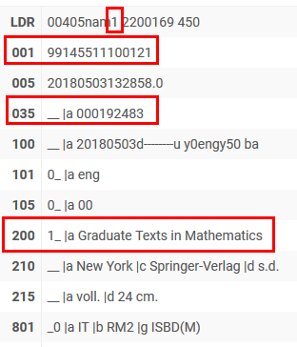 | 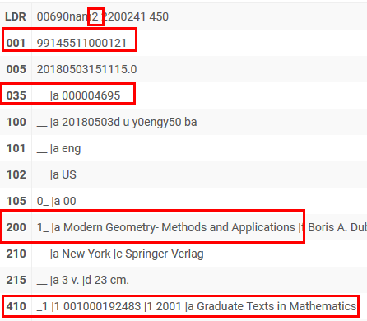 | 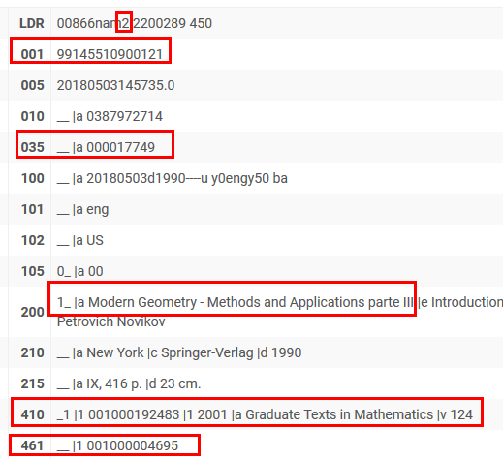

The Alma Search

Each record shows relationship(s) to other records in the Alma repository search tab “other details” tab

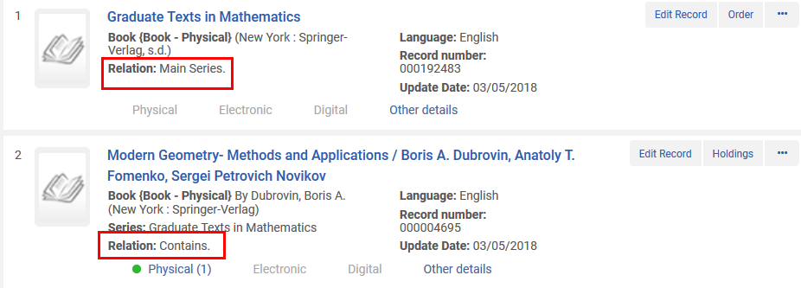

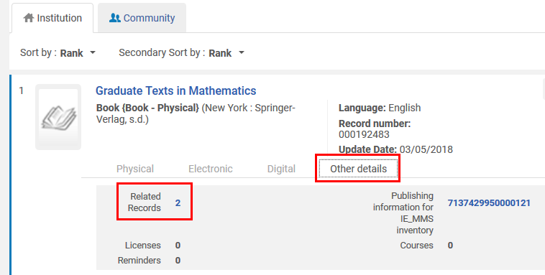

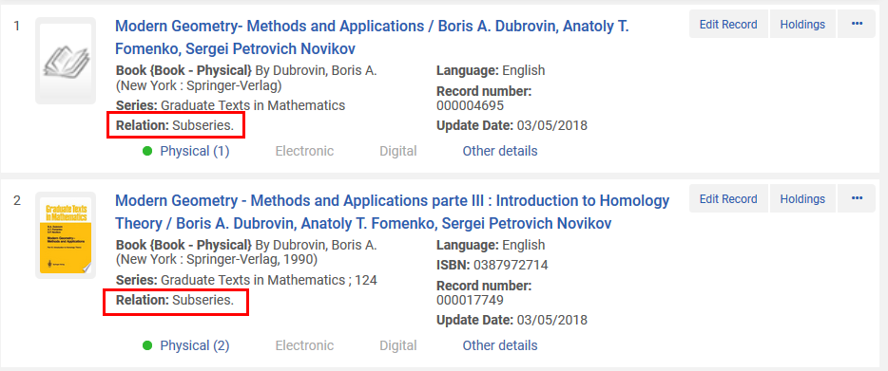

The Primo GetIt tab with related title information

Here is how the GetIt tab appears of we search for ‘Modern Geometry - Methods and Applications parte III’; MMSID 99145510900121

